目标端备份
停库
postgres=# select pg_switch_wal();
postgres=# select pg_switch_wal();
postgres=# checkpoint;
postgres=# checkpoint;

保存参数文件:
cd $PGDATA
mkdir /tmp/bak0223
ll /tmp/bak0223
cp postgresql.conf* /tmp/bak0223
cp /pg_log/klk1/postgresql-2021-02-23.log /tmp/bak0223

备份1：
pg_ctl stop
cd $PGDATA #/data/pgdata/pg1921/data_test
cd ..

备份数据目录：
mv data_test data_test_bak0223 #data_test 为pgdata最后一个目录
mkdir data_test
chmod 700 data_test

备份wal日志：
cd /data/pgdata/pg1921/
mkdir wal_bak0223
cp -r /data1/wal_test/ wal_bak0223 #备份wal到wal_bak0223

备份2：
物理备份
全备：
pgbackrest --stanza=klk1 --type=full --log-level-console=info backup --pg1-port=1921
打包压缩：
tar -zcvf db_bak0223.tar.gz pgbackrest
mv db_bak0223.tar.gz /tmp/ 或者 $PGDATA/..

备份3:

恢复演练过程
源库

full backup:
cat /etc/pgbackrest/pgbackrest.conf
pgbackrest --stanza=klk --type=full --log-level-console=info backup --pg1-port=1921
postgres=# create table important_table (message text,tt timestamp);
postgres=# insert into important_table values ('Important Data',current_timestamp);
INSERT 0 1

postgres=# select * from important_table;
message | tt
----------------+----------------------------
Important Data | 2021-02-23 09:30:27.651356
(1 row)

incre backup:
pgbackrest --stanza=klk --log-level-console=info --type=incr backup --pg1-port=1921

pgbackrest info

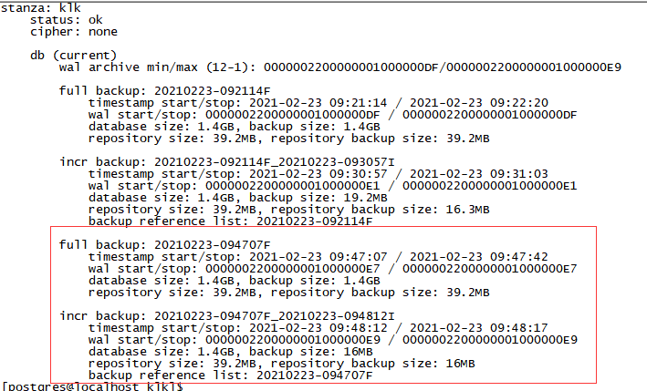

。。。。。
。。。。。

postgres=# create table important_table1 (message text,tt timestamp);
postgres=# insert into important_table1 values ('Important Data',current_timestamp);
INSERT 0 1
postgres=# select pg_switch_wal();

pg_switch_wal
---------------
1/E20001B8
(1 row)

postgres=# select pg_switch_wal();
pg_switch_wal
---------------
1/E3000078
(1 row)

postgres=# checkpoint;
CHECKPOINT

cat /etc/pgbackrest/pgbackrest.conf
cd /var/lib/pgbackrest

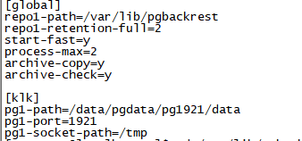

cd /var/lib/pgbackrest/backup/klk/
先清空目标端 : /var/lib/pgbackrest/backup/klk1/
scp -r /var/lib/pgbackrest/backup/klk/* 192.168.145.12:/var/lib/pgbackrest/backup/klk1/

cd /var/lib/pgbackrest/archive/klk/
先清空192.168.145.12:/var/lib/pgbackrest/archive/klk1/
scp -r /var/lib/pgbackrest/archive/klk/* 192.168.145.12:/var/lib/pgbackrest/archive/klk1/

目标库
cd /var/lib/pgbackrest/backup/klk1/
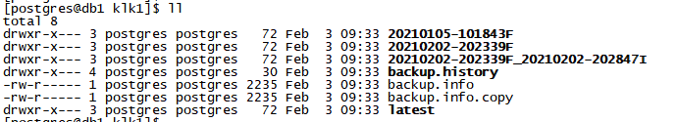
rm -rf latest

完全恢复

目标库：
pgbackrest --stanza=klk1 --delta --log-level-console=detail restore
cat postgresql.auto.conf
(pg11就是recovery.cnf)

如果是完全恢复：
对比源库，目标库的pg_wal,把源库未归档的日志传到目标库pg_wal：

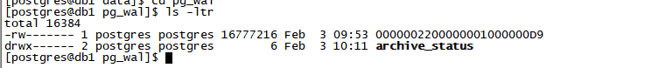

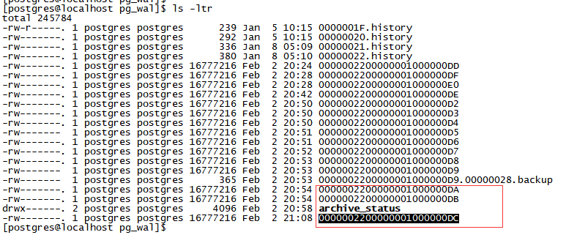

启动目标库并验证
替换参数文件 （注意修改路径）

禁止连接
vi pg_hba.conf
在最前面加
host all all 0.0.0.0/0 reject

启动
pg_ctl start

验证
postgres=# select * from important_table ;
message | tt
----------------+----------------------------
Important Data | 2021-02-23 09:30:27.651356
Important Data | 2021-02-23 09:31:52.861253
Important Data | 2021-02-23 09:48:05.511659

datamask

开放连接
vi pg_hba.conf
去掉
host all all 0.0.0.0/0 reject
pg_ctl reload

应用验证

清空恢复的数据库以及备份文件
停库：
pg_ctl stop

删除数据文件
cd $PGDATA/..
ll
rm -rf data_test (!!千万别删错,或者先重命名为data_test_delete0223)

删除备份文件和归档：
cd /var/lib/pgbackrest/backup/klk1/
rm -rf *
cd /var/lib/pgbackrest/archive/klk1/
rm -rf *

恢复UAT环境

恢复1
恢复数据目录
cd $PGDATA/..
cp -r data_test_bak0223 data_test
ll

恢复备份归档功能
cat /etc/pgbackrest/pgbackrest.conf
pgbackrest --stanza=klk1 --log-level-console=info stop
pgbackrest --stanza=klk1 --log-level-console=info stanza-delete
(--force 不用停库)
pg_ctl start
pgbackrest --stanza=klk1 --log-level-console=info stanza-create --pg1-port=1921 --config=/etc/pgbackrest/pgbackrest.conf

pg_switch_wal()

pgbackrest --stanza=klk1 --type=full --log-level-console=info backup --pg1-port=1921 --config=/etc/pgbackrest/pgbackrest.conf

pgbackrest info

待运行正常
删除 data_test_bak wal_bak0223

恢复2
cat /etc/pgbackrest/pgbackrest.conf
cd /var/lib/pgbackrest
mv /tmp/db_bak0223.tar.gz /var/lib/pgbackrest
tar -zxvf db_bak0223.tar.gz
pgbackrest --stanza=klk1 --delta --log-level-console=detail restore
pg_ctl start

压缩解压命令
备份归档存放地方
[postgres@db1 pgbackrest]$ ll
total 0
drwxr-x--- 3 postgres postgres 18 Feb 23 23:29 archive
drwxr-x--- 3 postgres postgres 18 Feb 23 23:29 backup

[postgres@db1 pgbackrest]$ pwd
/var/lib/pgbackrest

压缩
cd /var/lib/
tar -zcvf pgbackrest.tar.gz pgbackrest
会保留源文件：
drwxr-xr-x 9 root root 282 Feb 6 03:06 pgbackrest
-rw-r--r-- 1 root root 428 Feb 6 03:09 pgbackrest.tar.gz

解压
tar -zxvf pgbackrest.tar.gz
会保留源文件

